Introduction to Tree – Data Structure and Algorithm Tutorials

A tree data structure is a hierarchical structure that is used to represent and organize data in a way that is easy to navigate and search.
It is a collection of nodes that are connected by edges and has a hierarchical relationship between the nodes.
The topmost node of the tree is called the root, and the nodes below it are called the child nodes. Each node can have multiple child nodes, and these child nodes can also have their own child nodes, forming a recursive structure.
This data structure is a specialized method to organize and store data in the computer to be used more effectively. It consists of a central node, structural nodes, and sub-nodes, which are connected via edges. We can also say that tree data structure has roots, branches, and leaves connected.

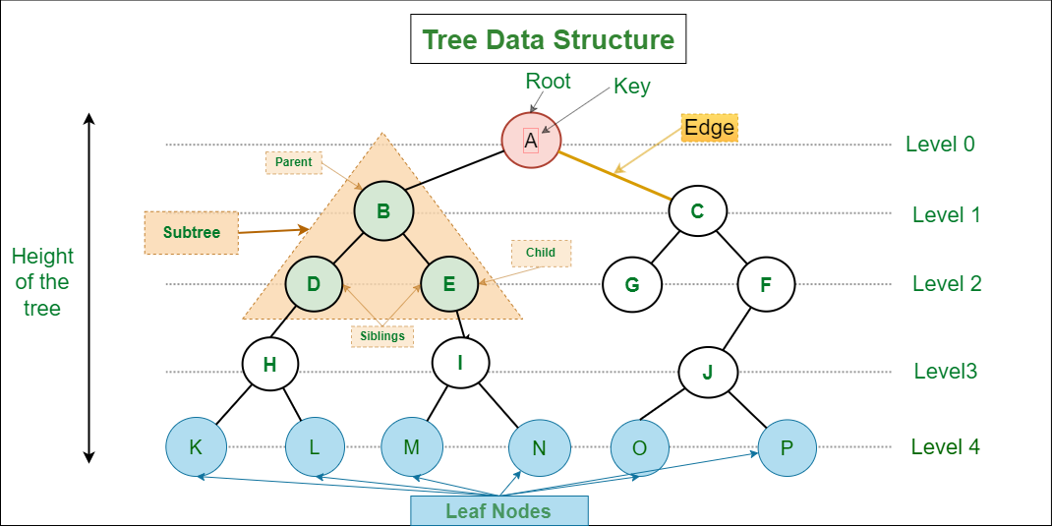

Basic Terminologies In Tree Data Structure:
- Parent Node: The node which is a predecessor of a node is called the parent node of that node. {B} is the parent node of {D, E}.
- Child Node: The node which is the immediate successor of a node is called the child node of that node. Examples: {D, E} are the child nodes of {B}.
- Root Node: The topmost node of a tree or the node which does not have any parent node is called the root node. {A} is the root node of the tree. A non-empty tree must contain exactly one root node and exactly one path from the root to all other nodes of the tree.
- Leaf Node or External Node: The nodes which do not have any child nodes are called leaf nodes. {K, L, M, N, O, P, G} are the leaf nodes of the tree.
- Ancestor of a Node: Any predecessor nodes on the path of the root to that node are called Ancestors of that node. {A,B} are the ancestor nodes of the node {E}
- Descendant: A node x is a descendant of another node y if and only if y is an ancestor of y.
- Sibling: Children of the same parent node are called siblings. {D,E} are called siblings.
- Level of a node: The count of edges on the path from the root node to that node. The root node has level 0.
- Internal node: A node with at least one child is called Internal Node.
- Neighbour of a Node: Parent or child nodes of that node are called neighbors of that node.
- Subtree: Any node of the tree along with its descendant.

Representation of Tree Data Structure:
A tree consists of a root, and zero or more subtrees T1, T2, … , Tk such that there is an edge from the root of the tree to the root of each subtree.
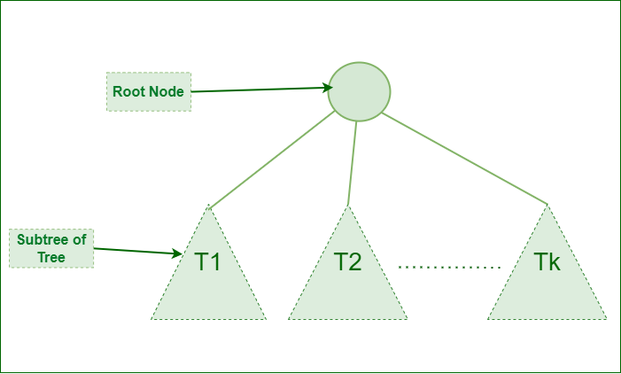
Representation of Tree Data Structure

Representation of a Node in Tree Data Structure:
struct Node
{
int data;
struct Node *first_child;
struct Node *second_child;
struct Node *third_child;
.
.
.
struct Node *nth_child;
};

Example of Tree data structure
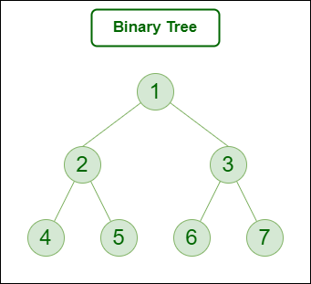
Here,
- Node 1 is the root node
- 1 is the parent of 2 and 3
- 2 and 3 are the siblings
- 4, 5, 6, and 7 are the leaf nodes
- 1 and 2 are the ancestors of 5

Types of Tree data structures:
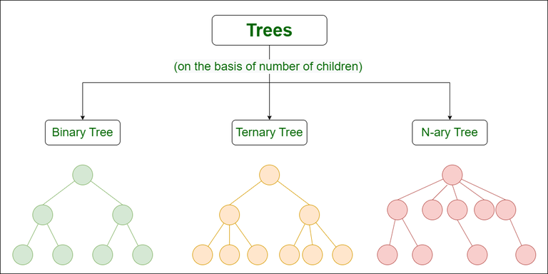
- Binary tree: In a binary tree, each node can have a maximum of two children linked to it. Some common types of binary trees include full binary trees, complete binary trees, balanced binary trees, and degenerate or pathological binary trees.
- Ternary Tree: A Ternary Tree is a tree data structure in which each node has at most three child nodes, usually distinguished as “left”, “mid” and “right”.
- N-ary Tree or Generic Tree: Generic trees are a collection of nodes where each node is a data structure that consists of records and a list of references to its children(duplicate references are not allowed). Unlike the linked list, each node stores the address of multiple nodes.
To learn more about types of trees, refer to this article.

Basic Operation Of Tree Data Structure:
- Create – create a tree in the data structure.
- Insert − Inserts data in a tree.
- Search − Searches specific data in a tree to check whether it is present or not.
- Traversal:
  - Preorder Traversal – perform Traveling a tree in a pre-order manner in the data structure.
  - In order Traversal – perform Traveling a tree in an in-order manner.
  - Post-order Traversal –perform Traveling a tree in a post-order manner.

Why Tree is considered a non-linear data structure?
The data in a tree are not stored in a sequential manner i.e., they are not stored linearly. Instead, they are arranged on multiple levels or we can say it is a hierarchical structure. For this reason, the tree is considered to be a non-linear data structure.

Properties of Tree Data Structure:
- Number of edges: An edge can be defined as the connection between two nodes. If a tree has N nodes then it will have (N-1) edges. There is only one path from each node to any other node of the tree.
- Depth of a node: The depth of a node is defined as the length of the path from the root to that node. Each edge adds 1 unit of length to the path. So, it can also be defined as the number of edges in the path from the root of the tree to the node.
- Height of a node: The height of a node can be defined as the length of the longest path from the node to a leaf node of the tree.
- Height of the Tree: The height of a tree is the length of the longest path from the root of the tree to a leaf node of the tree.
- Degree of a Node: The total count of subtrees attached to that node is called the degree of the node. The degree of a leaf node must be 0. The degree of a tree is the maximum degree of a node among all the nodes in the tree.

Application of Tree Data Structure:
- File System: This allows for efficient navigation and organization of files.
- Data Compression: Huffman coding is a popular technique for data compression that involves constructing a binary tree where the leaves represent characters and their frequency of occurrence. The resulting tree is used to encode the data in a way that minimizes the amount of storage required.
- Compiler Design: In compiler design, a syntax tree is used to represent the structure of a program.
- Database Indexing: B-trees and other tree structures are used in database indexing to efficiently search for and retrieve data.
.

Advantages of Tree Data Structure:
- Tree offer Efficient Searching Depending on the type of tree, with average search times of O(log n) for balanced trees like AVL.
- Trees provide a hierarchical representation of data, making it easy to organize and navigate large amounts of information.
- The recursive nature of trees makes them easy to traverse and manipulate using recursive algorithms.

Disadvantages of Tree Data Structure:
- Unbalanced Trees, meaning that the height of the tree is skewed towards one side, which can lead to inefficient search times.
- Trees demand more memory space requirements than some other data structures like arrays and linked lists, especially if the tree is very large.
- The implementation and manipulation of trees can be complex and require a good understanding of the algorithms.

Tree Traversal - inorder, preorder and postorder
Traversing a tree means visiting every node in the tree. You might, for instance, want to add all the values in the tree or find the largest one. For all these operations, you will need to visit each node of the tree.
Linear data structures like arrays, stacks, queues, and linked list have only one way to read the data. But a hierarchical data structure like a tree can be traversed in different ways.

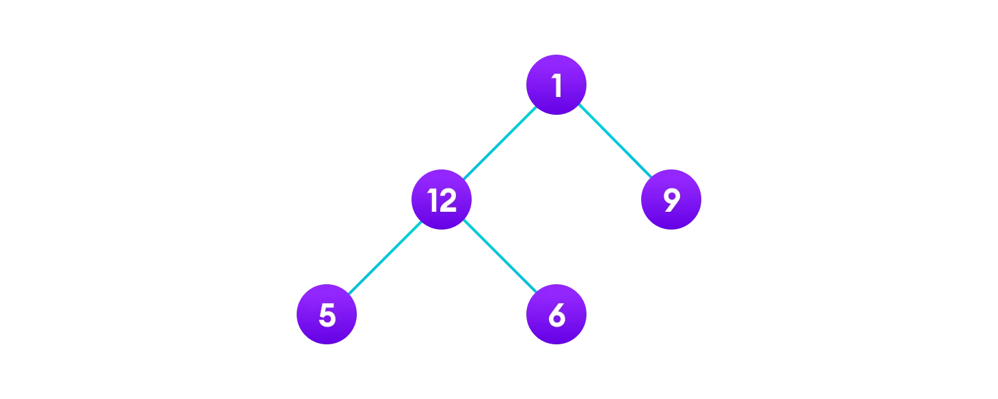

we use traversal methods that take into account the basic structure of a tree i.e.
struct node {
int data;
struct node* left;
struct node* right;
}
The struct node pointed to by left and right might have other left and right children so we should think of them as sub-trees instead of sub-nodes.

According to this structure, every tree is a combination of
- A node carrying data
- Two subtrees

In traversal our goal is to visit each node, so we need to visit all the nodes in the subtree, visit the root node and visit all the nodes in the right subtree as well.
Depending on the order in which we do this, there can be three types of traversal.
- Inorder Traversal
- Preorder Traversal
- Postorder Traversal

Inorder traversal
- First, visit all the nodes in the left subtree
- Then the root node
- Visit all the nodes in the right subtree
inorder(root->left)
display(root->data)
inorder(root->right)
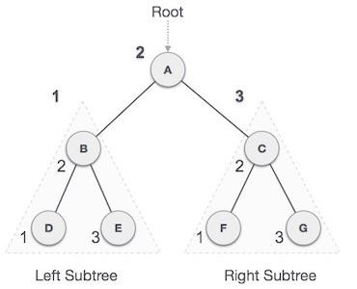
D → B → E → A → F → C → G

Preorder traversal
- Visit root node
- Visit all the nodes in the left subtree
- Visit all the nodes in the right subtree
display(root->data)
preorder(root->left)
preorder(root->right)
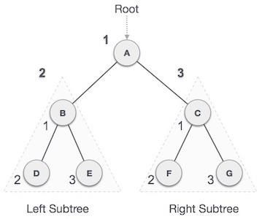
A → B → D → E → C → F → G

Postorder traversal
- Visit all the nodes in the left subtree
- Visit all the nodes in the right subtree
- Visit the root node

postorder(root->left)
postorder(root->right)
display(root->data)

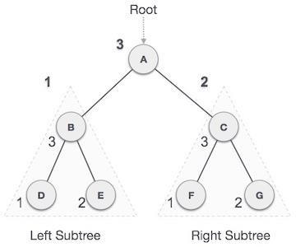

D → E → B → F → G → C → A
Example-

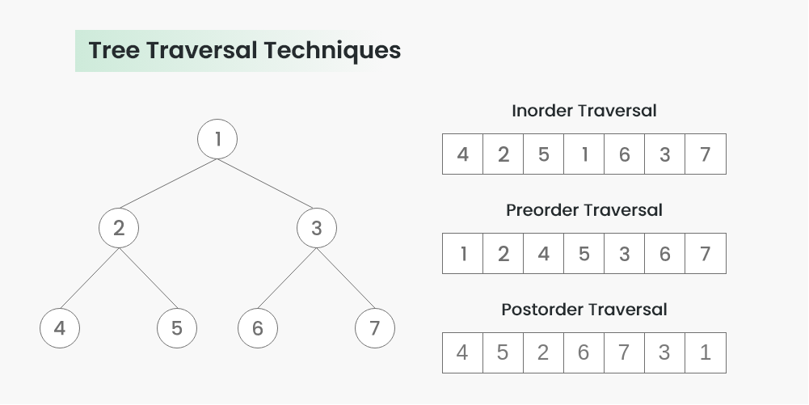

Binary Tree
The Binary tree means that the node can have maximum two children. Here, binary name itself suggests that 'two'; therefore, each node can have either 0, 1 or 2 children.
Ex-
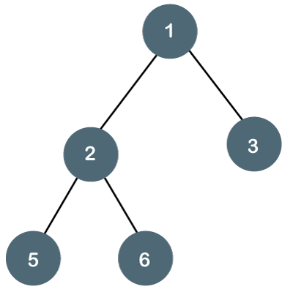
The above tree is a binary tree because each node contains the utmost two children. The logical representation of the above tree is given below:
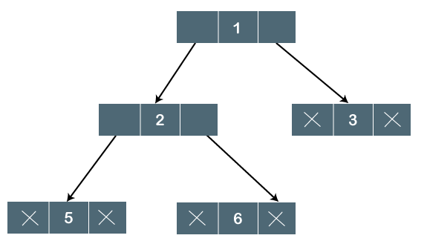

In the above tree, node 1 contains two pointers, i.e., left and a right pointer pointing to the left and right node respectively. The node 2 contains both the nodes (left and right node); therefore, it has two pointers (left and right). The nodes 3, 5 and 6 are the leaf nodes, so all these nodes contain NULL pointer on both left and right parts.

Properties of Binary Tree
- At each level of i, the maximum number of nodes is 2^{i}.
- The height of the tree is defined as the longest path from the root node to the leaf node. The tree which is shown above has a height equal to 3. Therefore, the maximum number of nodes at height 3 is equal to (1+2+4+8) = 15. In general, the maximum number of nodes possible at height h is (2⁰ + 2¹ + 2²+….2^{h}) = 2^{h+1} -1.
- The minimum number of nodes possible at height h is equal to h+1.
- If the number of nodes is minimum, then the height of the tree would be maximum. Conversely, if the number of nodes is maximum, then the height of the tree would be minimum.
If there are 'n' number of nodes in the binary tree.
The minimum height can be computed as:
As we know that,
n = 2^{h+1} -1
n+1 = 2^{h+1}
Taking log on both the sides,
log₂(n+1) = log2(2^{h+1})
log₂(n+1) = h+1
h = log₂(n+1) - 1
The maximum height can be computed as:
As we know that,
n = h+1
h= n-1

Types of Binary Tree
There are four types of Binary tree:
- Full/ proper/ strict Binary tree
- Complete Binary tree
- Perfect Binary tree
- Degenerate Binary tree
- Balanced Binary tree
1. Full/ proper/ strict Binary tree
The full binary tree is also known as a strict binary tree. The tree can only be considered as the full binary tree if each node must contain either 0 or 2 children. The full binary tree can also be defined as the tree in which each node must contain 2 children except the leaf nodes.
Let's look at the simple example of the Full Binary tree.
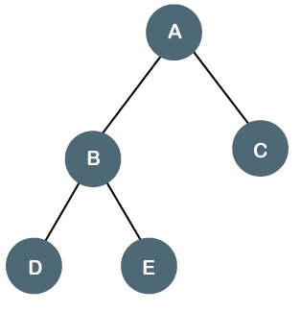
In the above tree, we can observe that each node is either containing zero or two children; therefore, it is a Full Binary tree.
Properties of Full Binary Tree
- The number of leaf nodes is equal to the number of internal nodes plus 1. In the above example, the number of internal nodes is 5; therefore, the number of leaf nodes is equal to 6.
- The maximum number of nodes is the same as the number of nodes in the binary tree, i.e., 2^{h+1} -1.
- The minimum number of nodes in the full binary tree is 2*h-1.
- The minimum height of the full binary tree is log₂(n+1) - 1.
- The maximum height of the full binary tree can be computed as:
n= 2*h - 1
n+1 = 2*h
h = n+1/2
Complete Binary Tree
The complete binary tree is a tree in which all the nodes are completely filled except the last level. In the last level, all the nodes must be as left as possible. In a complete binary tree, the nodes should be added from the left.
Let's create a complete binary tree.
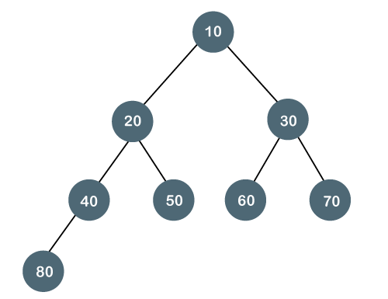
The above tree is a complete binary tree because all the nodes are completely filled, and all the nodes in the last level are added at the left first.
Properties of Complete Binary Tree
- The maximum number of nodes in complete binary tree is 2^{h+1} - 1.
- The minimum number of nodes in complete binary tree is 2^{h}.
- The minimum height of a complete binary tree is log₂(n+1) - 1.
- The maximum height of a complete binary tree is
Perfect Binary Tree
A tree is a perfect binary tree if all the internal nodes have 2 children, and all the leaf nodes are at the same level.
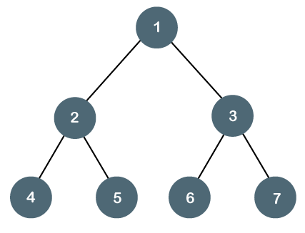
Let's look at a simple example of a perfect binary tree.
The below tree is not a perfect binary tree because all the leaf nodes are not at the same level.
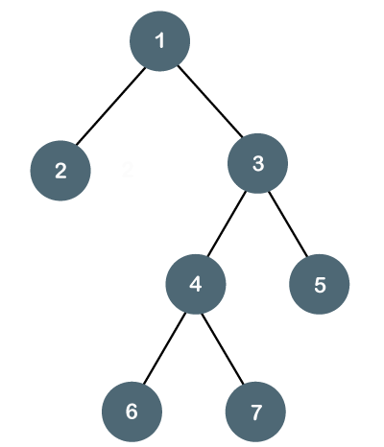

Note: All the perfect binary trees are the complete binary trees as well as the full binary tree, but vice versa is not true, i.e., all complete binary trees and full binary trees are the perfect binary trees.

Degenerate Binary Tree
The degenerate binary tree is a tree in which all the internal nodes have only one children.
Let's understand the Degenerate binary tree through examples.
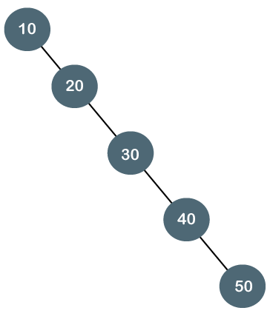
The above tree is a degenerate binary tree because all the nodes have only one child. It is also known as a right-skewed tree as all the nodes have a right child only.
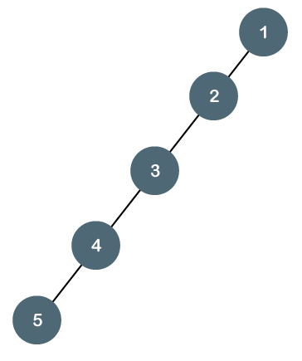
The above tree is also a degenerate binary tree because all the nodes have only one child. It is also known as a left-skewed tree as all the nodes have a left child only.
Balanced Binary Tree
The balanced binary tree is a tree in which both the left and right trees differ by atmost 1. For example, AVL and Red-Black trees are balanced binary tree.
Let's understand the balanced binary tree through examples.
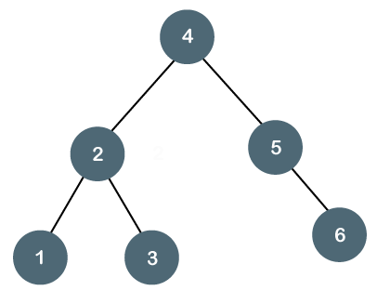
The above tree is a balanced binary tree because the difference between the left subtree
and right subtree is zero.

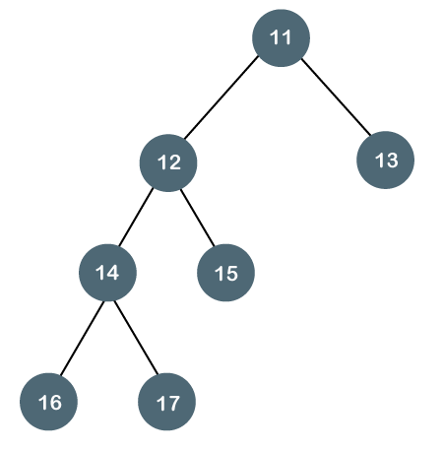
The above tree is not a balanced binary tree because the difference between the left subtree and the right subtree is greater than 1.

Threaded Binary Tree

Inorder traversal of a Binary tree can either be done using recursion or with the use of a auxiliary stack. The idea of threaded binary trees is to make inorder traversal faster and do it without stack and without recursion. A binary tree is made threaded by making all right child pointers that would normally be NULL point to the inorder successor of the node (if it exists).
A threaded binary tree is a type of binary tree data structure where the empty left and right child pointers in a binary tree are replaced with threads that link nodes directly to their in-order predecessor or successor, thereby providing a way to traverse the tree without using recursion or a stack.
Threaded binary trees can be useful when space is a concern, as they can eliminate the need for a stack during traversal. However, they can be more complex to implement than standard binary trees.
There are two types of threaded binary trees.
Single Threaded: Where a NULL right pointers is made to point to the inorder successor (if successor exists)
Double Threaded: Where both left and right NULL pointers are made to point to inorder predecessor and inorder successor respectively. The predecessor threads are useful for reverse inorder traversal and postorder traversal.
The threads are also useful for fast accessing ancestors of a node.
Following diagram shows an example Single Threaded Binary Tree. The dotted lines represent threads.
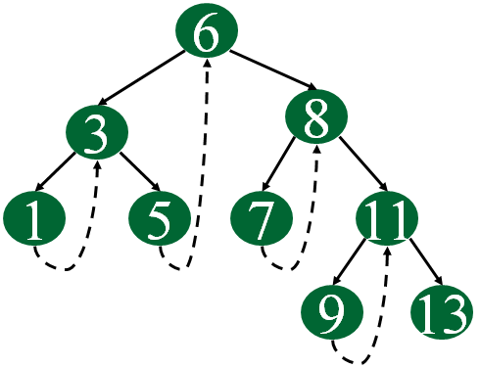
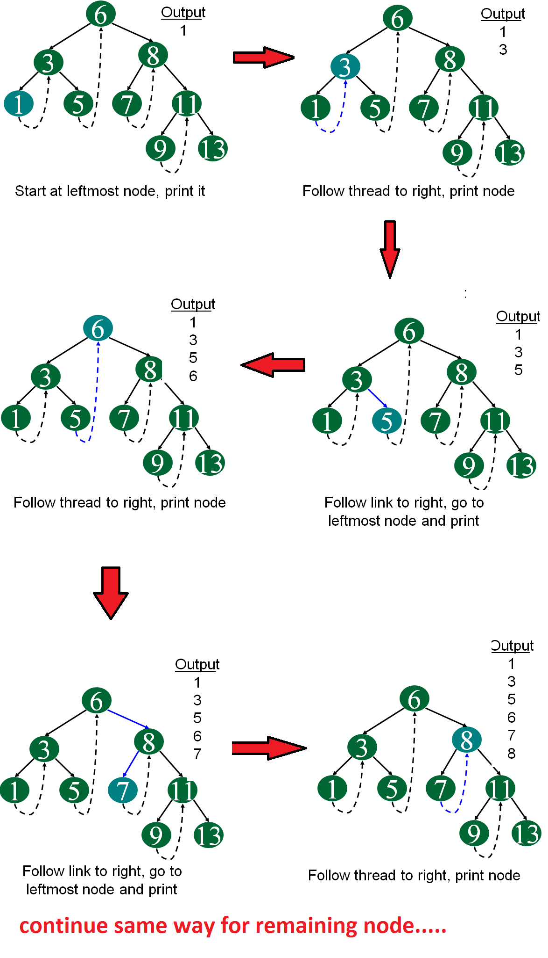
Advantages of Threaded Binary Tree
- In this Tree it enables linear traversal of elements.
- It eliminates the use of stack as it perform linear traversal, so save memory.
- Enables to find parent node without explicit use of parent pointer
- Threaded tree give forward and backward traversal of nodes by in-order fashion
- Nodes contain pointers to in-order predecessor and successor
- For a given node, we can easily find inorder predecessor and successor. So, searching is much more easier.
- In threaded binary tree there is no NULL pointer present. Hence memory wastage in occupying NULL links is avoided.
- The threads are pointing to successor and predecessor nodes. This makes us to obtain predecessor and successor node of any node quickly.
- There is no need of stack while traversing the tree, because using thread links we can reach to previously visited nodes.
Disadvantages of Threaded Binary Tree
- Every node in threaded binary tree need extra information(extra memory) to indicate whether its left or right node indicated its child nodes or its inorder predecessor or successor. So, the node consumes extra memory to implement.
- Insertion and deletion are way more complex and time consuming than the normal one since both threads and ordinary links need to be maintained.
- Implementing threads for every possible node is complicated.
- Increased complexity: Implementing a threaded binary tree requires more complex algorithms and data structures than a regular binary tree. This can make the code harder to read and debug.
- Extra memory usage: In some cases, the additional pointers used to thread the tree can use up more memory than a regular binary tree. This is especially true if the tree is not fully balanced, as threading a skewed tree can result in a large number of additional pointers.
- Limited flexibility: Threaded binary trees are specialized data structures that are optimized for specific types of traversal. While they can be more efficient than regular binary trees for these types of operations, they may not be as useful in other scenarios. For example, they cannot be easily modified (e.g. inserting or deleting nodes) without breaking the threading.
- Difficulty in parallelizing: It can be challenging to parallelize operations on a threaded binary tree, as the threading can introduce data dependencies that make it difficult to process nodes independently. This can limit the performance gains that can be achieved through parallelism.

Applications of threaded binary tree –
- Expression evaluation: Threaded binary trees can be used to evaluate arithmetic expressions in a way that avoids recursion or a stack. The tree can be constructed from the input expression, and then traversed in-order or pre-order to perform the evaluation.
- Database indexing: In a database, threaded binary trees can be used to index data based on a specific field (e.g. last name). The tree can be constructed with the indexed values as keys, and then traversed in-order to retrieve the data in sorted order.
- Symbol table management: In a compiler or interpreter, threaded binary trees can be used to store and manage symbol tables for variables and functions. The tree can be constructed with the symbols as keys, and then traversed in-order or pre-order to perform various operations on the symbol table.
- Disk-based data structures: Threaded binary trees can be used in disk-based data structures (e.g. B-trees) to improve performance. By threading the tree, it can be traversed in a way that minimizes disk seeks and improves locality of reference.
- Navigation of hierarchical data: In certain applications, threaded binary trees can be used to navigate hierarchical data structures, such as file systems or web site directories. The tree can be constructed from the hierarchical data, and then traversed in-order or pre-order to efficiently access the data in a specific order.

Binary Search tree
A binary search tree follows some order to arrange the elements. In a Binary search tree, the value of left node must be smaller than the parent node, and the value of right node must be greater than the parent node. This rule is applied recursively to the left and right subtrees of the root.
Let's understand the concept of Binary search tree with an example.
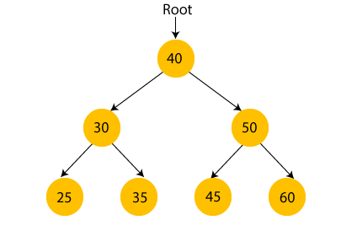
In the above figure, we can observe that the root node is 40, and all the nodes of the left subtree are smaller than the root node, and all the nodes of the right subtree are greater than the root node.
Similarly, we can see the left child of root node is greater than its left child and smaller than its right child. So, it also satisfies the property of binary search tree. Therefore, we can say that the tree in the above image is a binary search tree.
Suppose if we change the value of node 35 to 55 in the above tree, check whether the tree will be binary search tree or not.
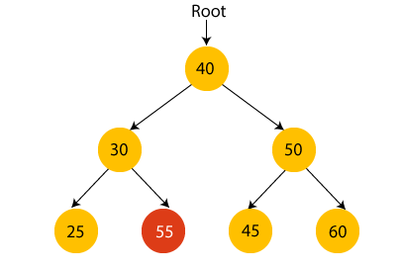
In the above tree, the value of root node is 40, which is greater than its left child 30 but smaller than right child of 30, i.e., 55. So, the above tree does not satisfy the property of Binary search tree. Therefore, the above tree is not a binary search tree.

Advantages of Binary search tree
- Searching an element in the Binary search tree is easy as we always have a hint that which subtree has the desired element.
- As compared to array and linked lists, insertion and deletion operations are faster in BST.

Example of creating a binary search tree
Now, let's see the creation of binary search tree using an example.
Suppose the data elements are - 45, 15, 79, 90, 10, 55, 12, 20, 50
- First, we have to insert 45 into the tree as the root of the tree.
- Then, read the next element; if it is smaller than the root node, insert it as the root of the left subtree, and move to the next element.
- Otherwise, if the element is larger than the root node, then insert it as the root of the right subtree.
Now, let's see the process of creating the Binary search tree using the given data element. The process of creating the BST is shown below -
Step 1 - Insert 45.
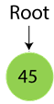
Step 2 - Insert 15.
As 15 is smaller than 45, so insert it as the root node of the left subtree.
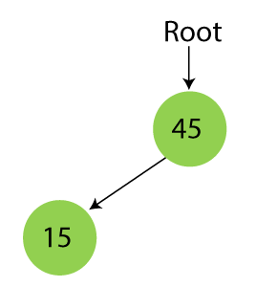
Step 3 - Insert 79.
As 79 is greater than 45, so insert it as the root node of the right subtree.
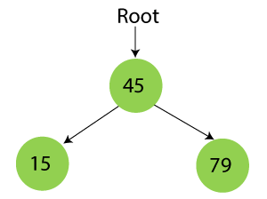
Step 4 - Insert 90.
90 is greater than 45 and 79, so it will be inserted as the right subtree of 79.
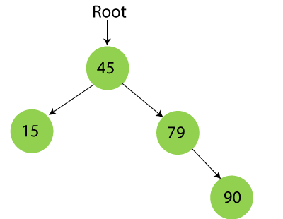
Step 5 - Insert 10.
10 is smaller than 45 and 15, so it will be inserted as a left subtree of 15.
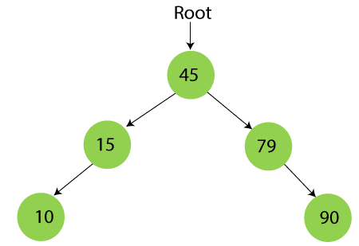
Step 6 - Insert 55.
55 is larger than 45 and smaller than 79, so it will be inserted as the left subtree of 79.
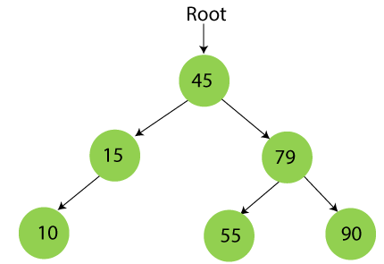
Step 7 - Insert 12.
12 is smaller than 45 and 15 but greater than 10, so it will be inserted as the right subtree of 10.
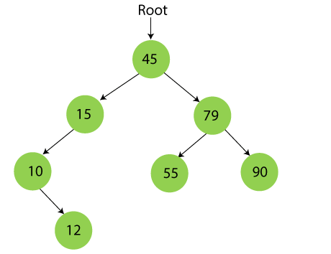
Step 8 - Insert 20.
20 is smaller than 45 but greater than 15, so it will be inserted as the right subtree of 15.
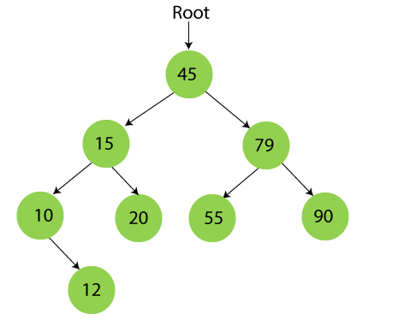
Step 9 - Insert 50.
50 is greater than 45 but smaller than 79 and 55. So, it will be inserted as a left subtree of 55.
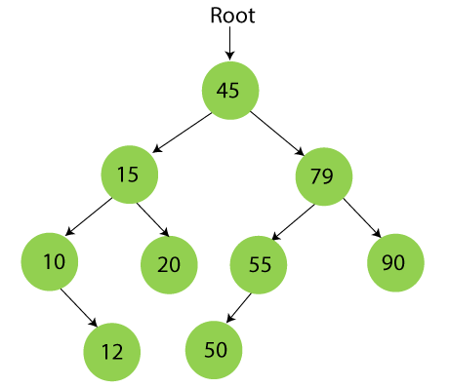
Now, the creation of binary search tree is completed. After that, let's move towards the operations that can be performed on Binary search tree.
We can perform insert, delete and search operations on the binary search tree.

Searching in Binary search tree
Searching means to find or locate a specific element or node in a data structure. In Binary search tree, searching a node is easy because elements in BST are stored in a specific order. The steps of searching a node in Binary Search tree are listed as follows -
- First, compare the element to be searched with the root element of the tree.
- If root is matched with the target element, then return the node's location.
- If it is not matched, then check whether the item is less than the root element, if it is smaller than the root element, then move to the left subtree.
- If it is larger than the root element, then move to the right subtree.
- Repeat the above procedure recursively until the match is found.
- If the element is not found or not present in the tree, then return NULL.
Now, let's understand the searching in binary tree using an example. We are taking the binary search tree formed above. Suppose we have to find node 20 from the below tree.
Step1:
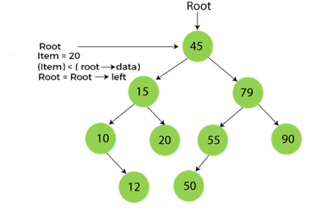
Step2:
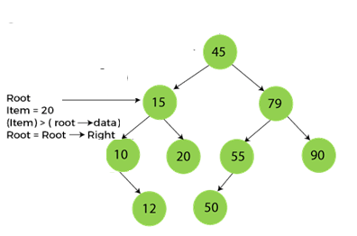
Step3:
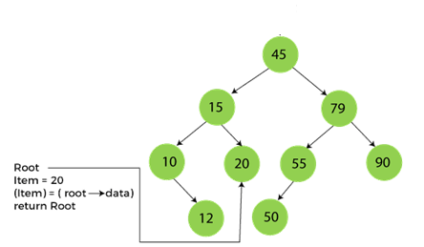
Now, let's see the algorithm to search an element in the Binary search tree.

Algorithm to search an element in Binary search tree
- Search (root, item)
- Step 1 - if (item = root → data) or (root = NULL)
- return root
- else if (item < root → data)
- return Search(root → left, item)
- else
- return Search(root → right, item)
- END if
- Step 2 - END
Now let's understand how the deletion is performed on a binary search tree. We will also see an example to delete an element from the given tree.

Deletion in Binary Search tree
In a binary search tree, we must delete a node from the tree by keeping in mind that the property of BST is not violated. To delete a node from BST, there are three possible situations occur -
- The node to be deleted is the leaf node, or,
- The node to be deleted has only one child, and,
- The node to be deleted has two children
We will understand the situations listed above in detail.
When the node to be deleted is the leaf node
It is the simplest case to delete a node in BST. Here, we have to replace the leaf node with NULL and simply free the allocated space.
We can see the process to delete a leaf node from BST in the below image. In below image, suppose we have to delete node 90, as the node to be deleted is a leaf node, so it will be replaced with NULL, and the allocated space will free.
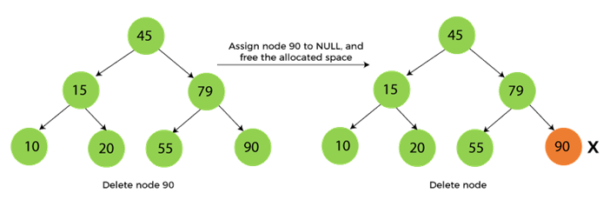
When the node to be deleted has only one child
In this case, we have to replace the target node with its child, and then delete the child node. It means that after replacing the target node with its child node, the child node will now contain the value to be deleted. So, we simply have to replace the child node with NULL and free up the allocated space.
We can see the process of deleting a node with one child from BST in the below image. In the below image, suppose we have to delete the node 79, as the node to be deleted has only one child, so it will be replaced with its child 55.
So, the replaced node 79 will now be a leaf node that can be easily deleted.
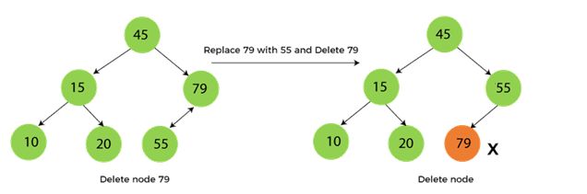
When the node to be deleted has two children
This case of deleting a node in BST is a bit complex among other two cases. In such a case, the steps to be followed are listed as follows -
- First, find the inorder successor of the node to be deleted.
- After that, replace that node with the inorder successor until the target node is placed at the leaf of tree.
- And at last, replace the node with NULL and free up the allocated space.
The inorder successor is required when the right child of the node is not empty. We can obtain the inorder successor by finding the minimum element in the right child of the node.
We can see the process of deleting a node with two children from BST in the below image. In the below image, suppose we have to delete node 45 that is the root node, as the node to be deleted has two children, so it will be replaced with its inorder successor. Now, node 45 will be at the leaf of the tree so that it can be deleted easily.
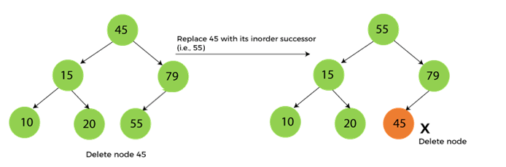
Now let's understand how insertion is performed on a binary search tree.

Insertion in Binary Search tree
A new key in BST is always inserted at the leaf. To insert an element in BST, we have to start searching from the root node; if the node to be inserted is less than the root node, then search for an empty location in the left subtree. Else, search for the empty location in the right subtree and insert the data. Insert in BST is similar to searching, as we always have to maintain the rule that the left subtree is smaller than the root, and right subtree is larger than the root.
Example-

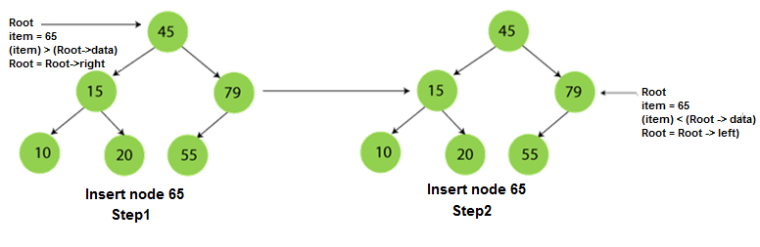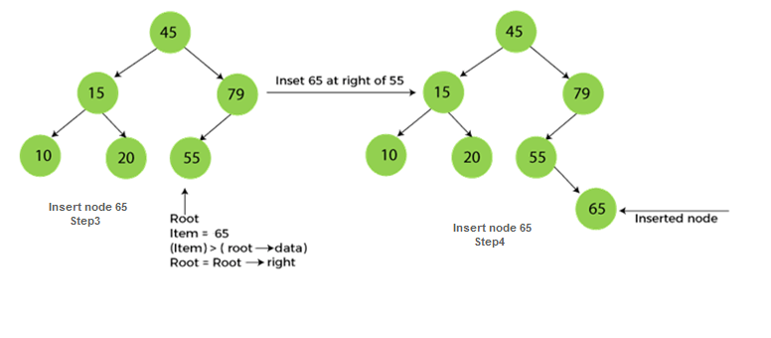

The complexity of the Binary Search tree
Let's see the time and space complexity of the Binary search tree. We will see the time complexity for insertion, deletion, and searching operations in best case, average case, and worst case.

1. Time Complexity
Operations | Best case time complexity | Average case time complexity | Worst case time complexity
Insertion | O(log n) | O(log n) | O(n)
Deletion | O(log n) | O(log n) | O(n)
Search | O(log n) | O(log n) | O(n)
Where 'n' is the number of nodes in the given tree.

2. Space Complexity
Operations | Space complexity
Insertion | O(n)
Deletion | O(n)
Search | O(n)
- The space complexity of all operations of Binary search tree is O(n).

